24.07- People Detection using VisDrone Dataset:

Gitlab repo: <https://gitlab.bewelltech.com.tr/Intern4/visdrone-object-detection>

Paddle Detection using VisDrone Dataset:

Page is on Chinese so its hard to read

<https://github.com/PaddlePaddle/PaddleDetection/tree/release/2.7>

YOLOE+

VisDrone Dataset:

Vision Meets Drones: A Challenge

<https://arxiv.org/abs/1804.07437>

*# Classes*

names:

0: pedestrian

1: people

2: bicycle

3: car

4: van

5: truck

6: tricycle

7: awning-tricycle

8: bus

9: motor

Dataset originally consist of followings:

Train:6471 images

Val: 548 images

Test-dev: 1610 images

Test(challenge): 1580 images

Subset:

Train: 500 images

Val: 100 images

Test-dev: 100 images

1. Creating random subset with Python script. See “data_reducer.py” on [GitHub](https://gitlab.bewelltech.com.tr/Intern4/visdrone-object-detection/-/blob/main/preprocess/data_reducer.py)
2. Data annotations converted to YOLO labels with Python Script. See “annotation_handler.py” on [GitHub](https://gitlab.bewelltech.com.tr/Intern4/visdrone-object-detection/-/blob/main/preprocess/annotation_handler.py)

Check [Colab notebook](https://gitlab.bewelltech.com.tr/Intern4/visdrone-object-detection/-/blob/main/yolos/yolov10/yolov10n_base_e10_bs16/VisDrone_yolov10n_base_test.ipynb):

YOLOV10n multiclass object detection model results with 10 epochs batch size = 16

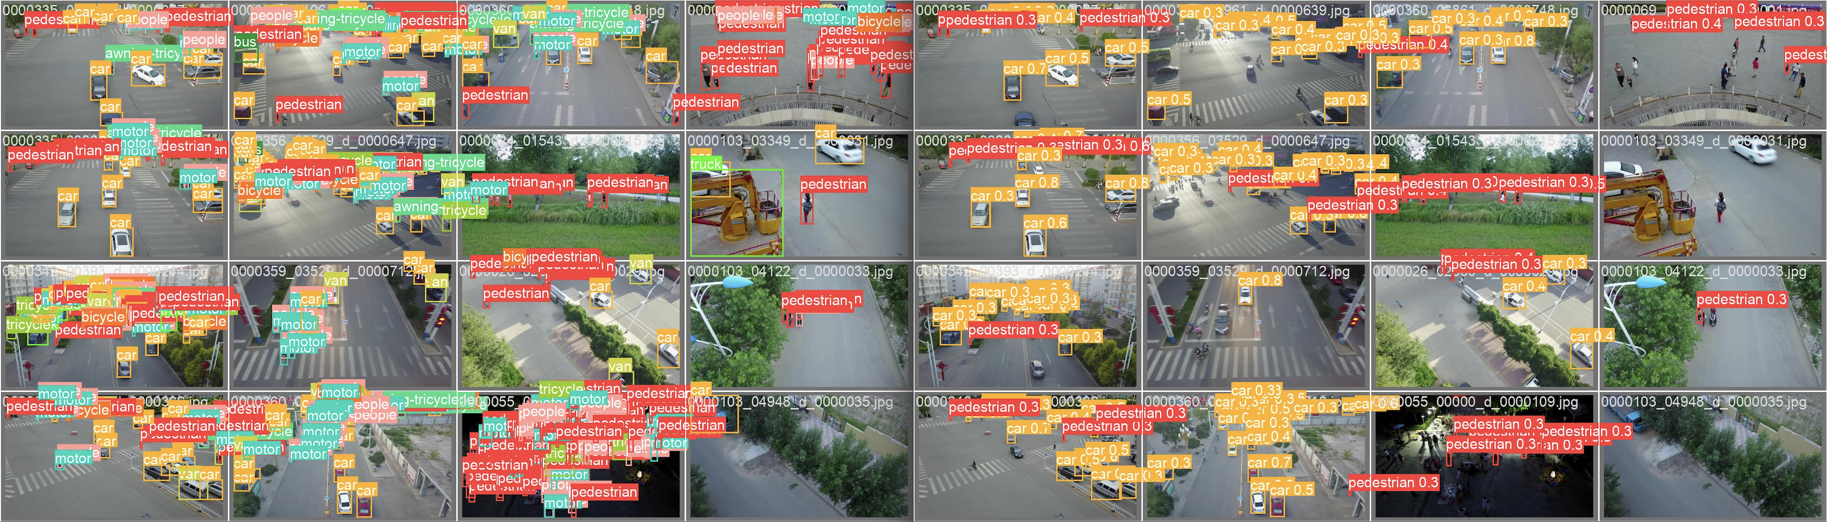 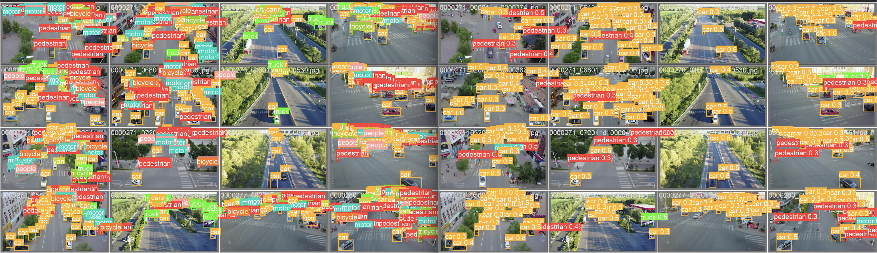

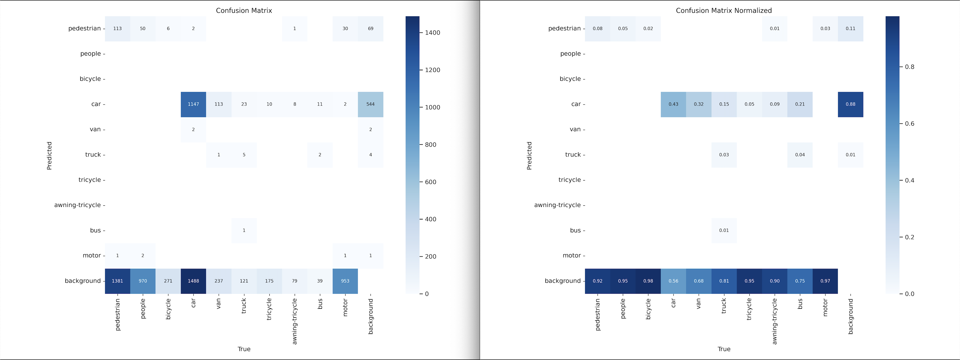

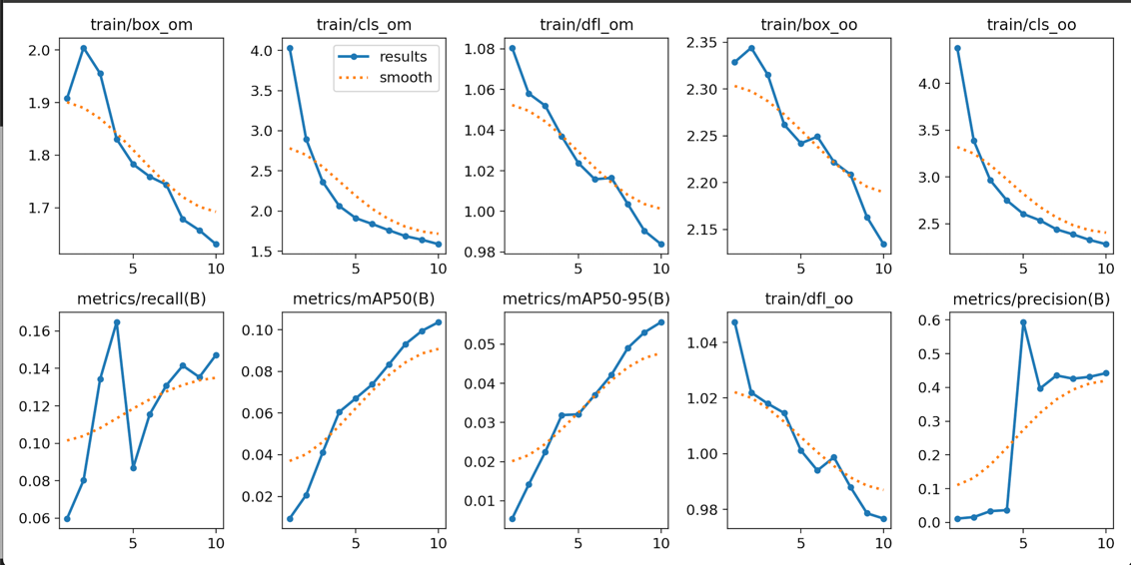

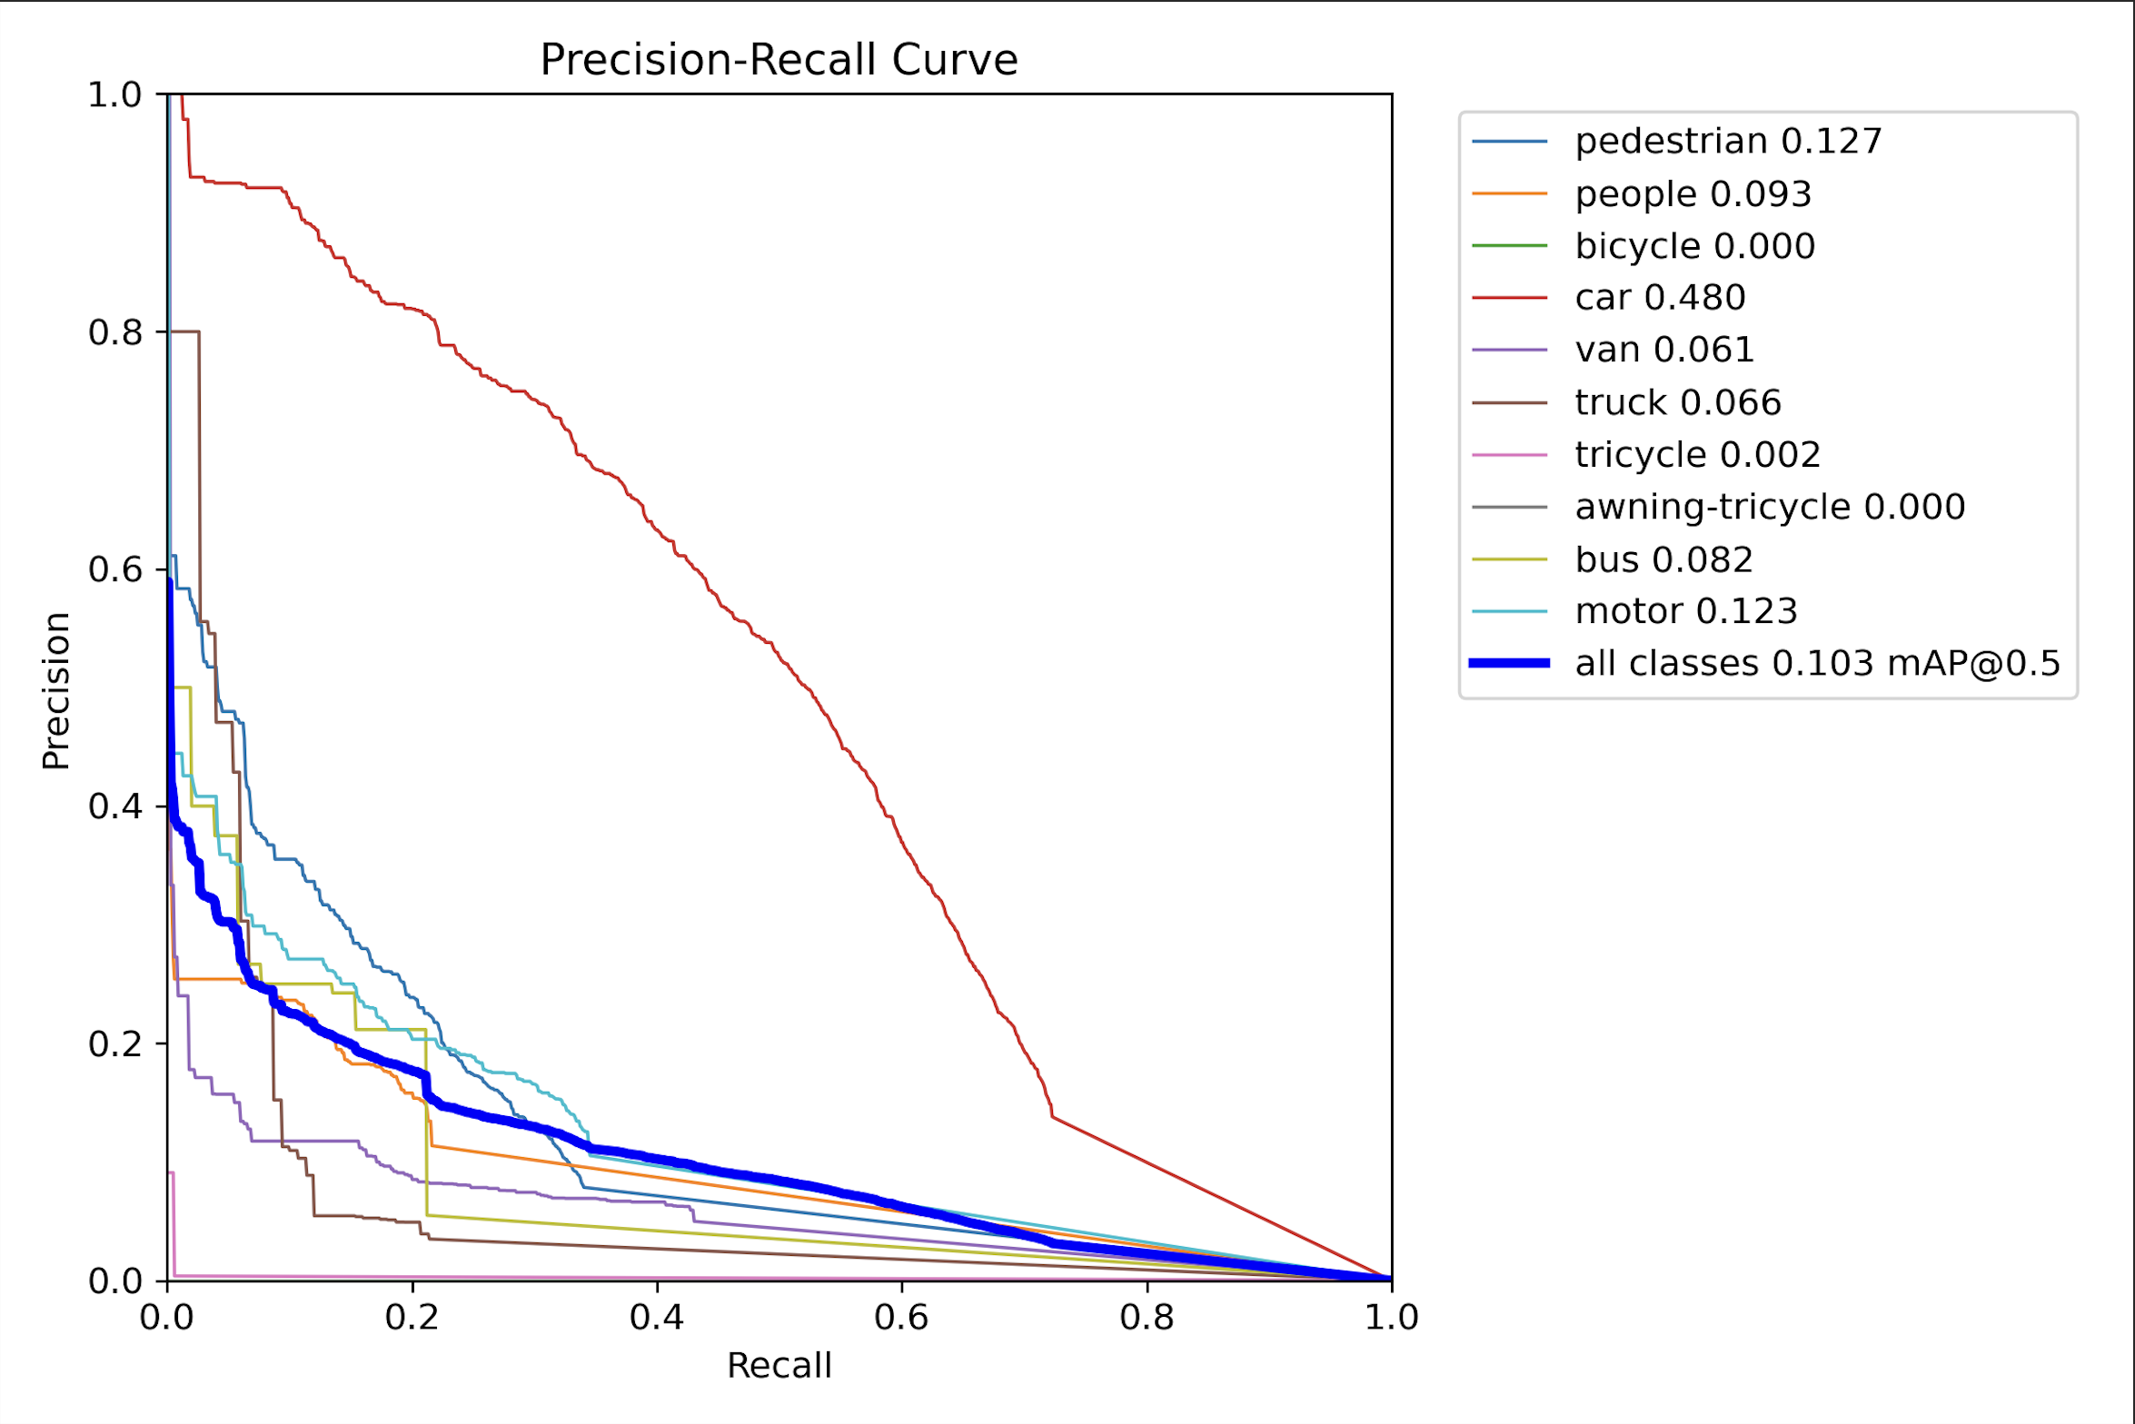

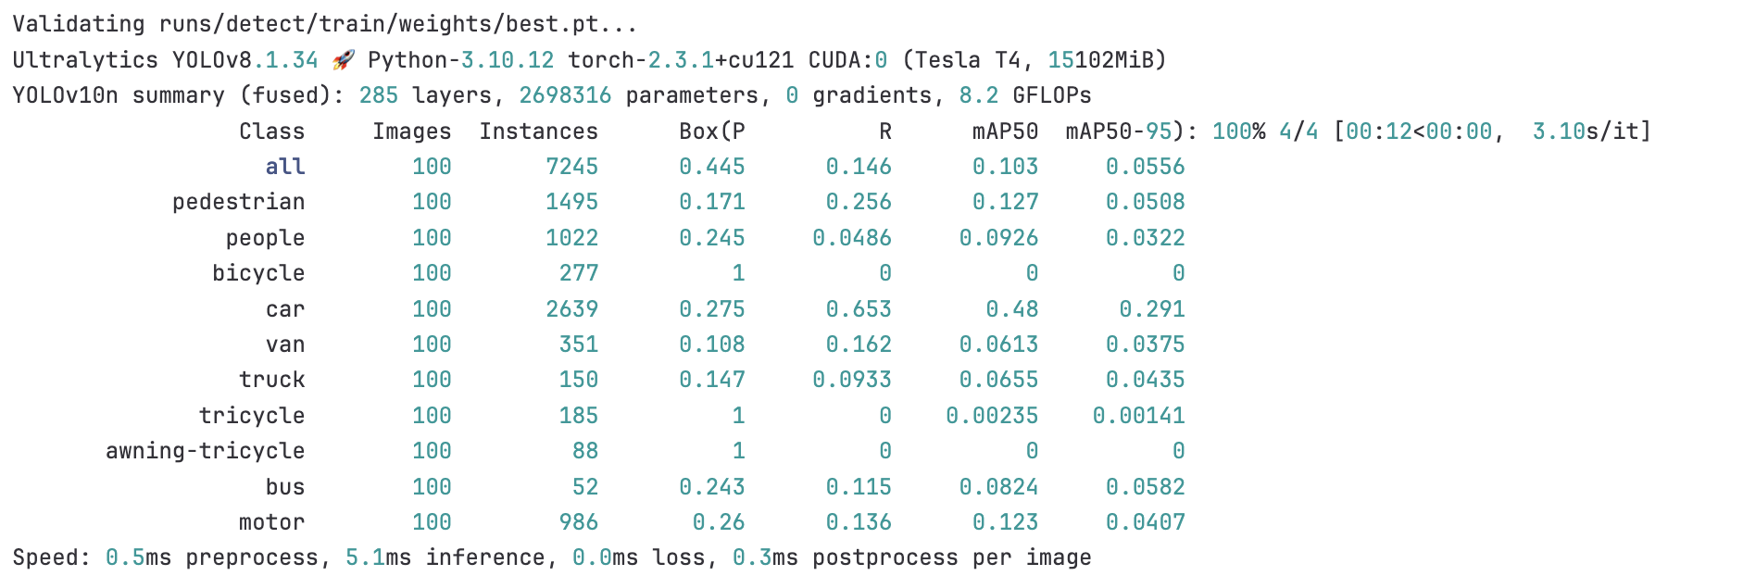

Comments and inferences on my perspective:

10 epochs is not enough for training phase and also there are too many classes.

TODO 1: decrease class size(eliminate unnecessary classes and merge some classes into one)

TODO 2: increase train epochs to 100

25.07- “Data Wrangling”

TODO 1: decrease class size (eliminate unnecessary classes and merge some classes into one)

• Combine class 0 (pedestrian) and 1 (people) to 0 (PERSON).

• Combine class 3 (car) 4 (van) 5(truck) 8(bus) and 9(motorcycle) to 1 (VEHICLE).

• Ignore class 2 (bicycle), 6 (tricycle), and 7 (awning-tricycle).

See updated python script “[annotation_handler.py](https://gitlab.bewelltech.com.tr/Intern4/visdrone-object-detection/-/blob/main/preprocess/annotation_handler.py)”

VisDrone.yaml file:

path: /content/data *# dataset root dir*

train: VisDrone2019-DET-train/images *# train images (relative to 'path') 6471 images*

val: VisDrone2019-DET-val/images *# val images (relative to 'path') 548 images*

test: VisDrone2019-DET-test-dev/images *# test images (optional) 1610 images*

*# Classes*

names:

0: person

1: vehicle

Yolov10n base run with new labels:

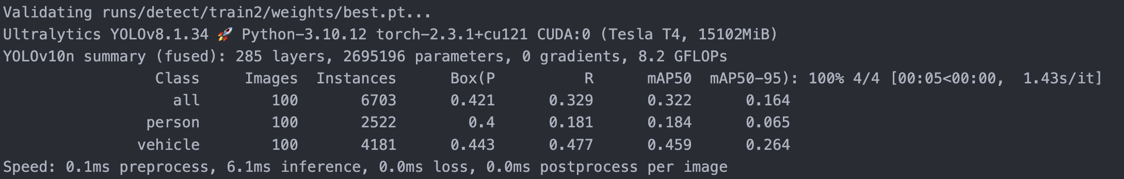

10 epochs bs16

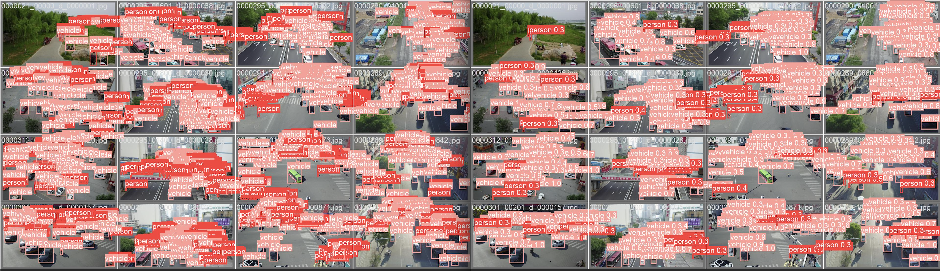

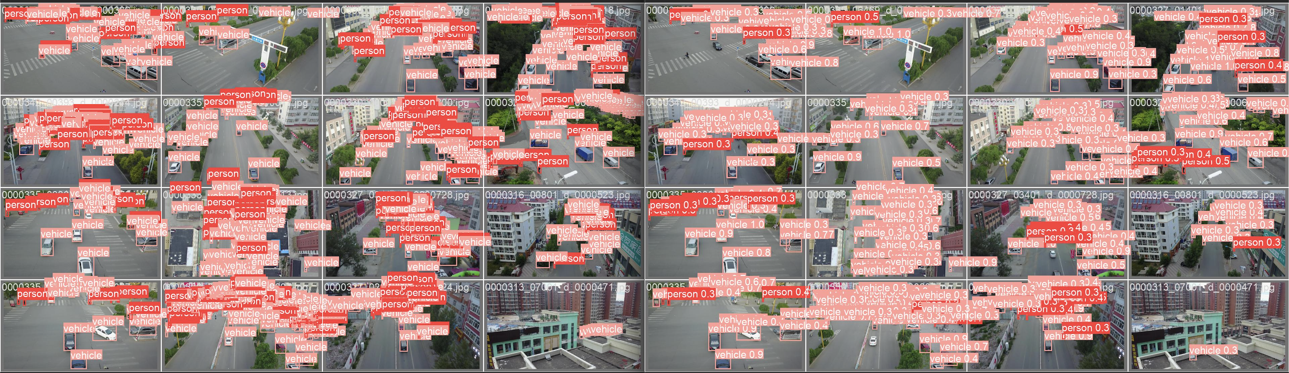

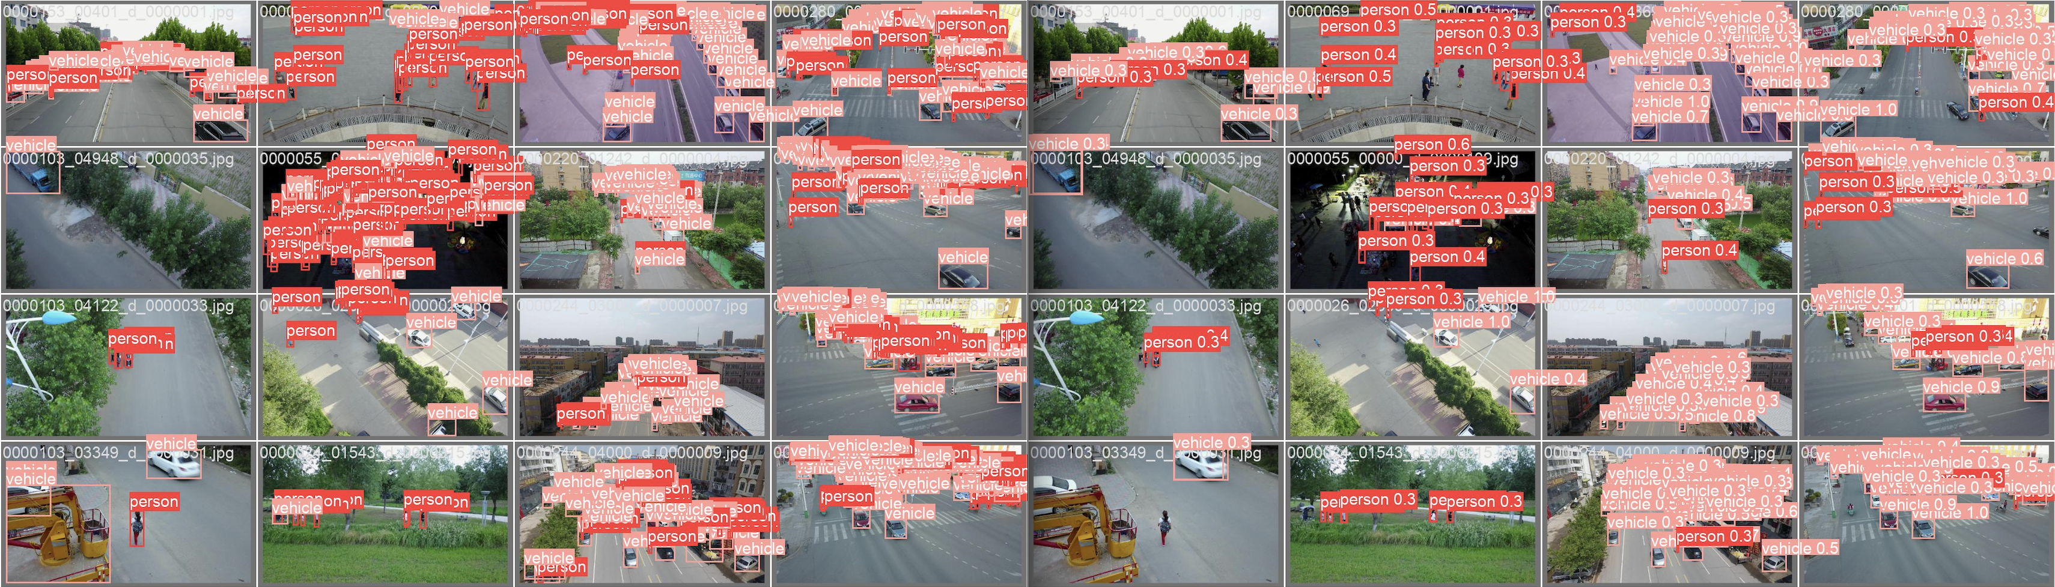

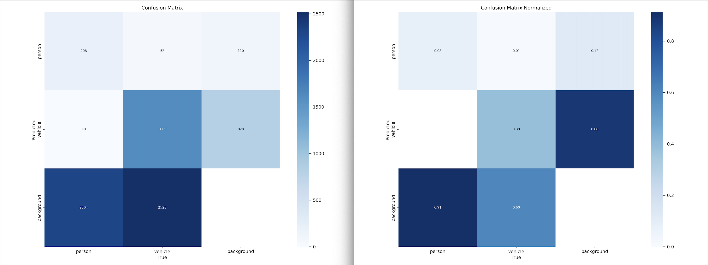

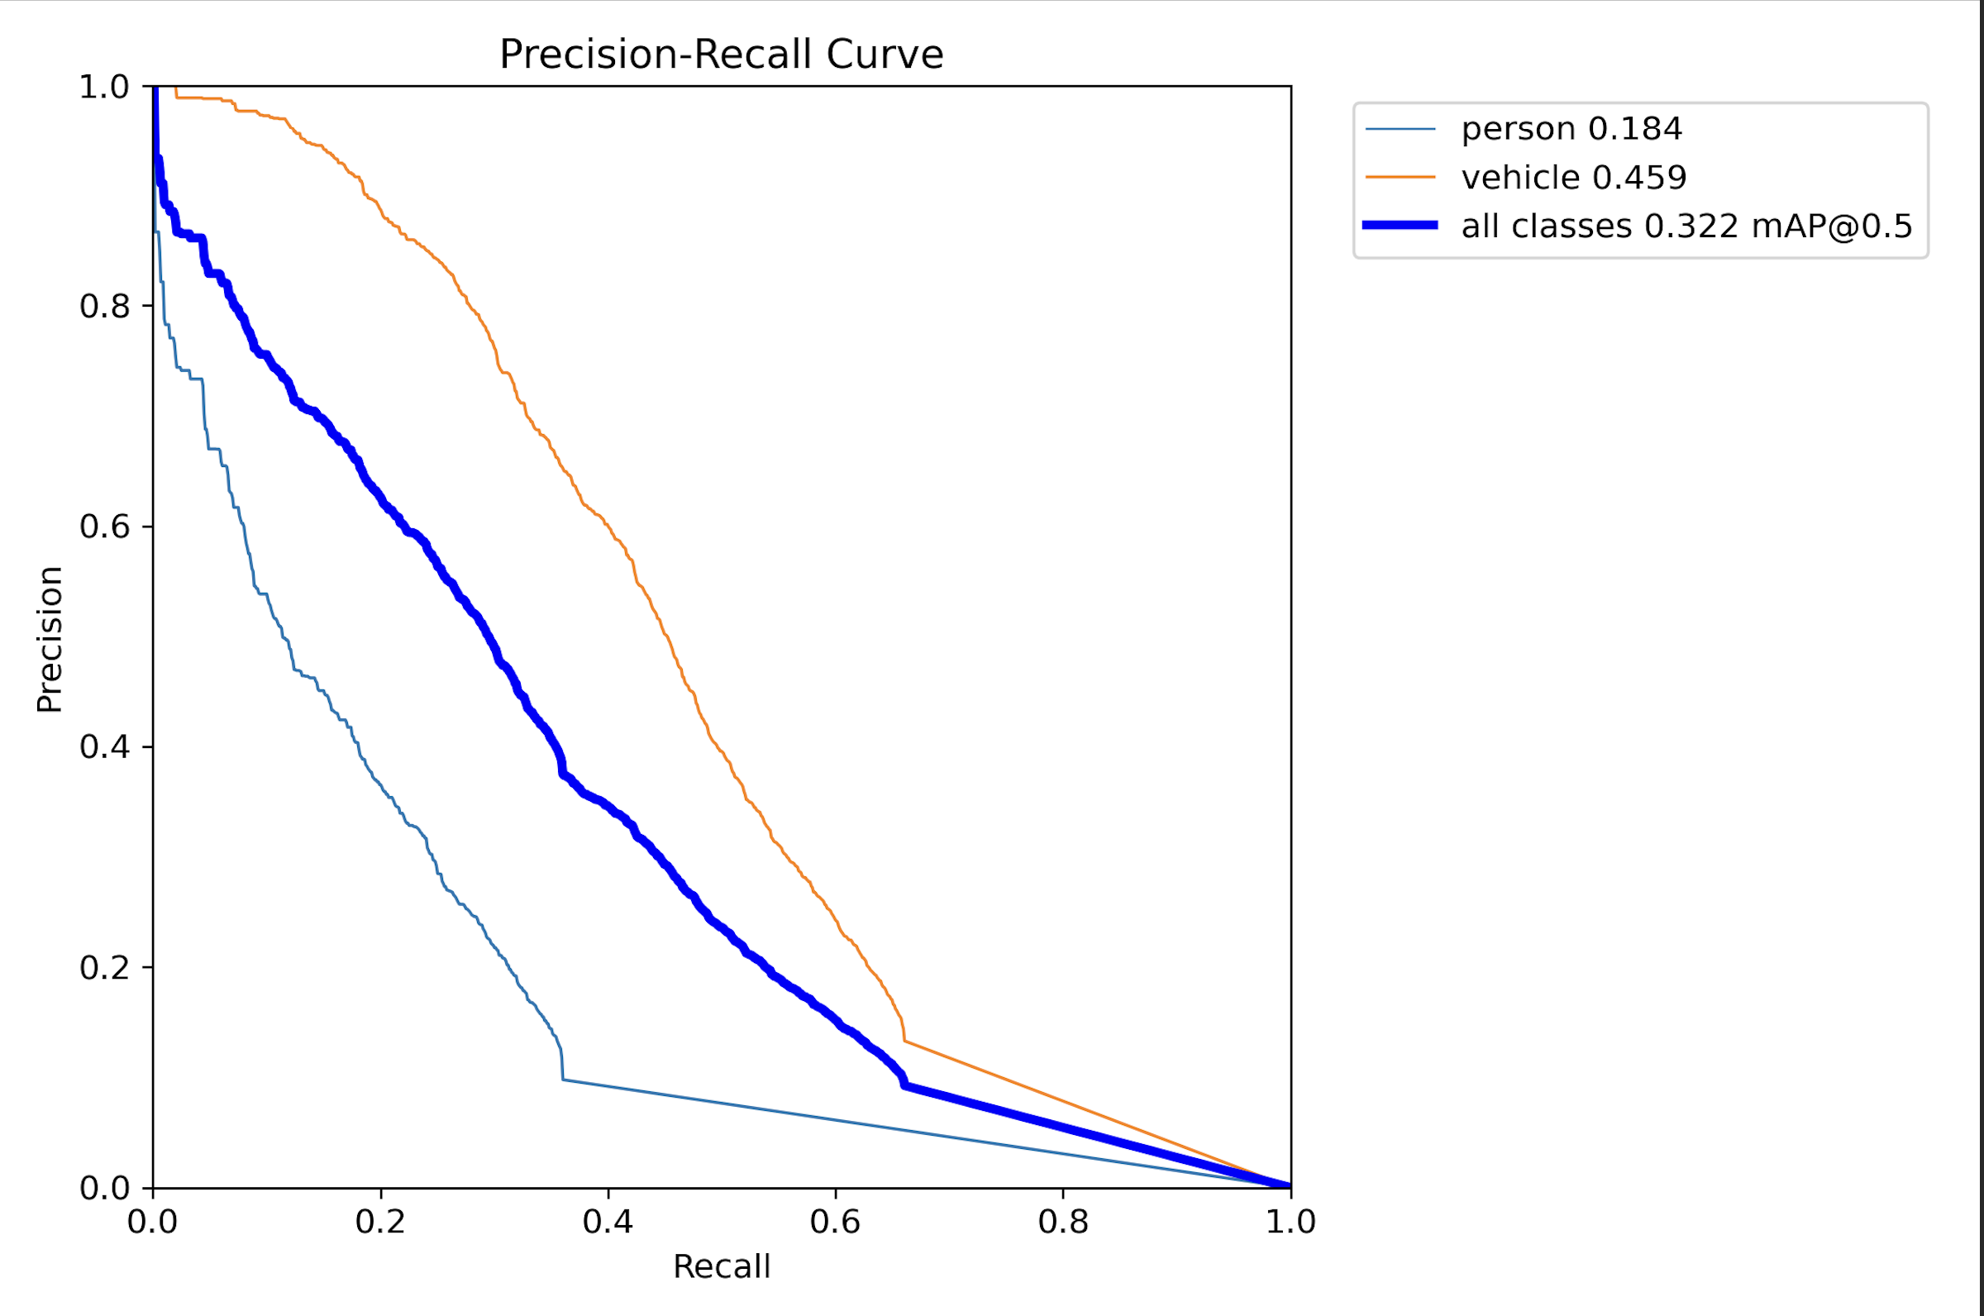

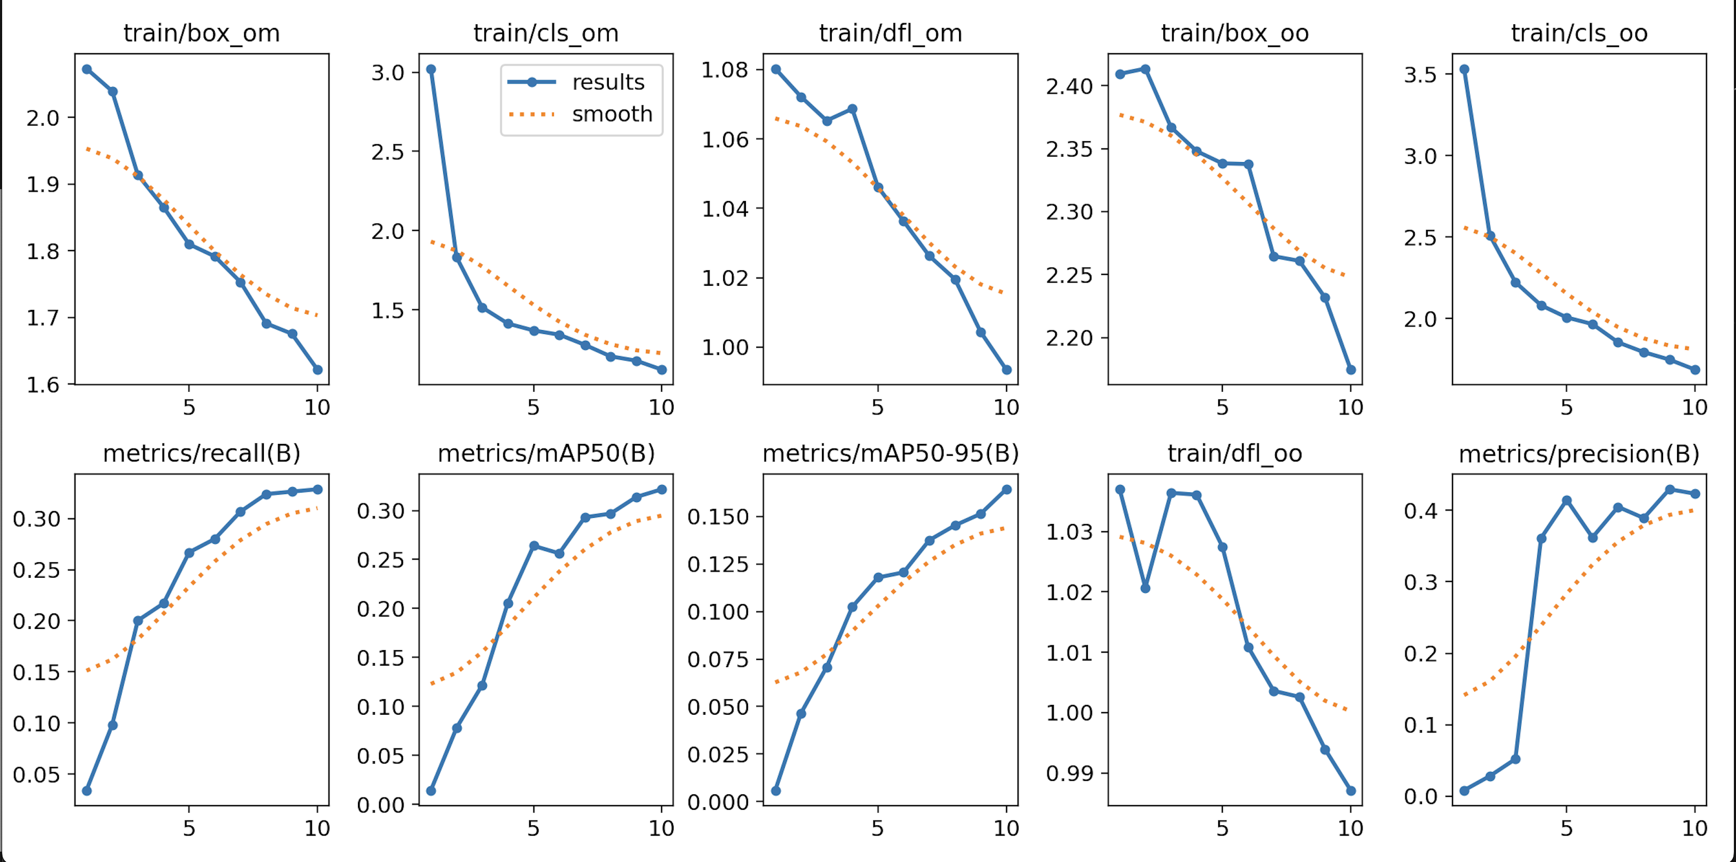

YOLOV10n run with custom labels 100 epoch batch size = 32

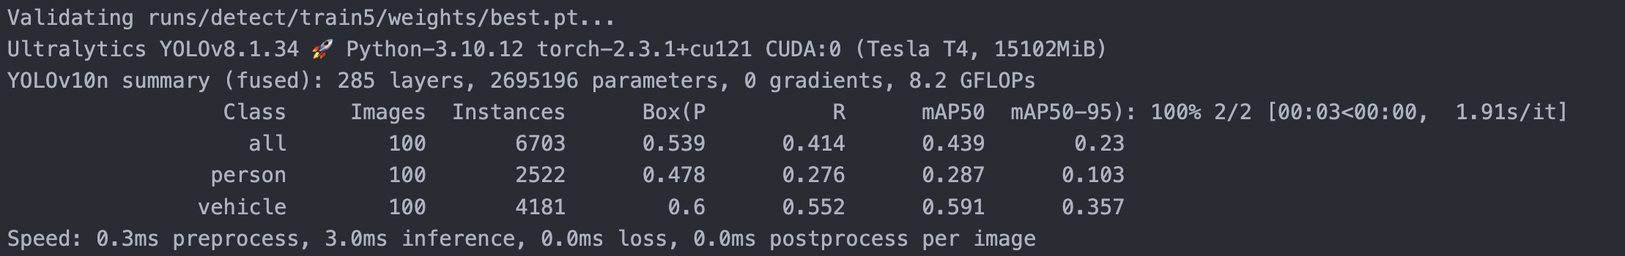

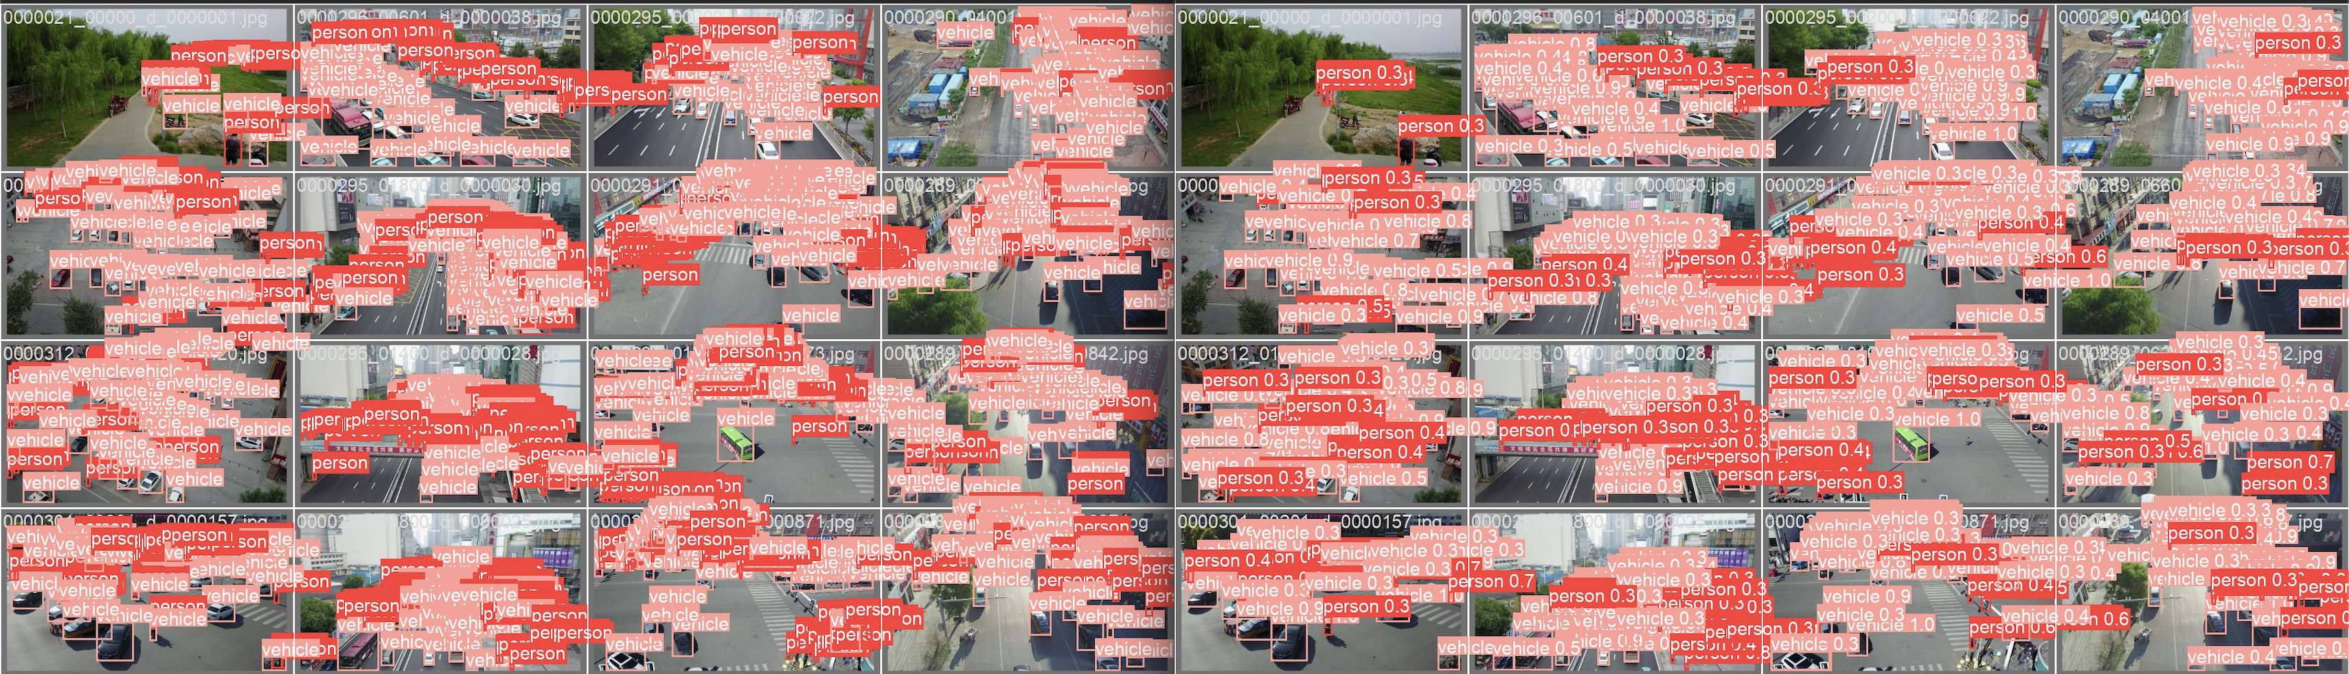

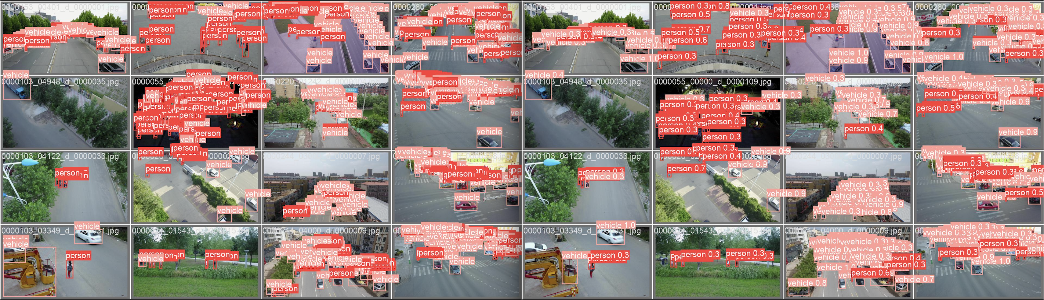

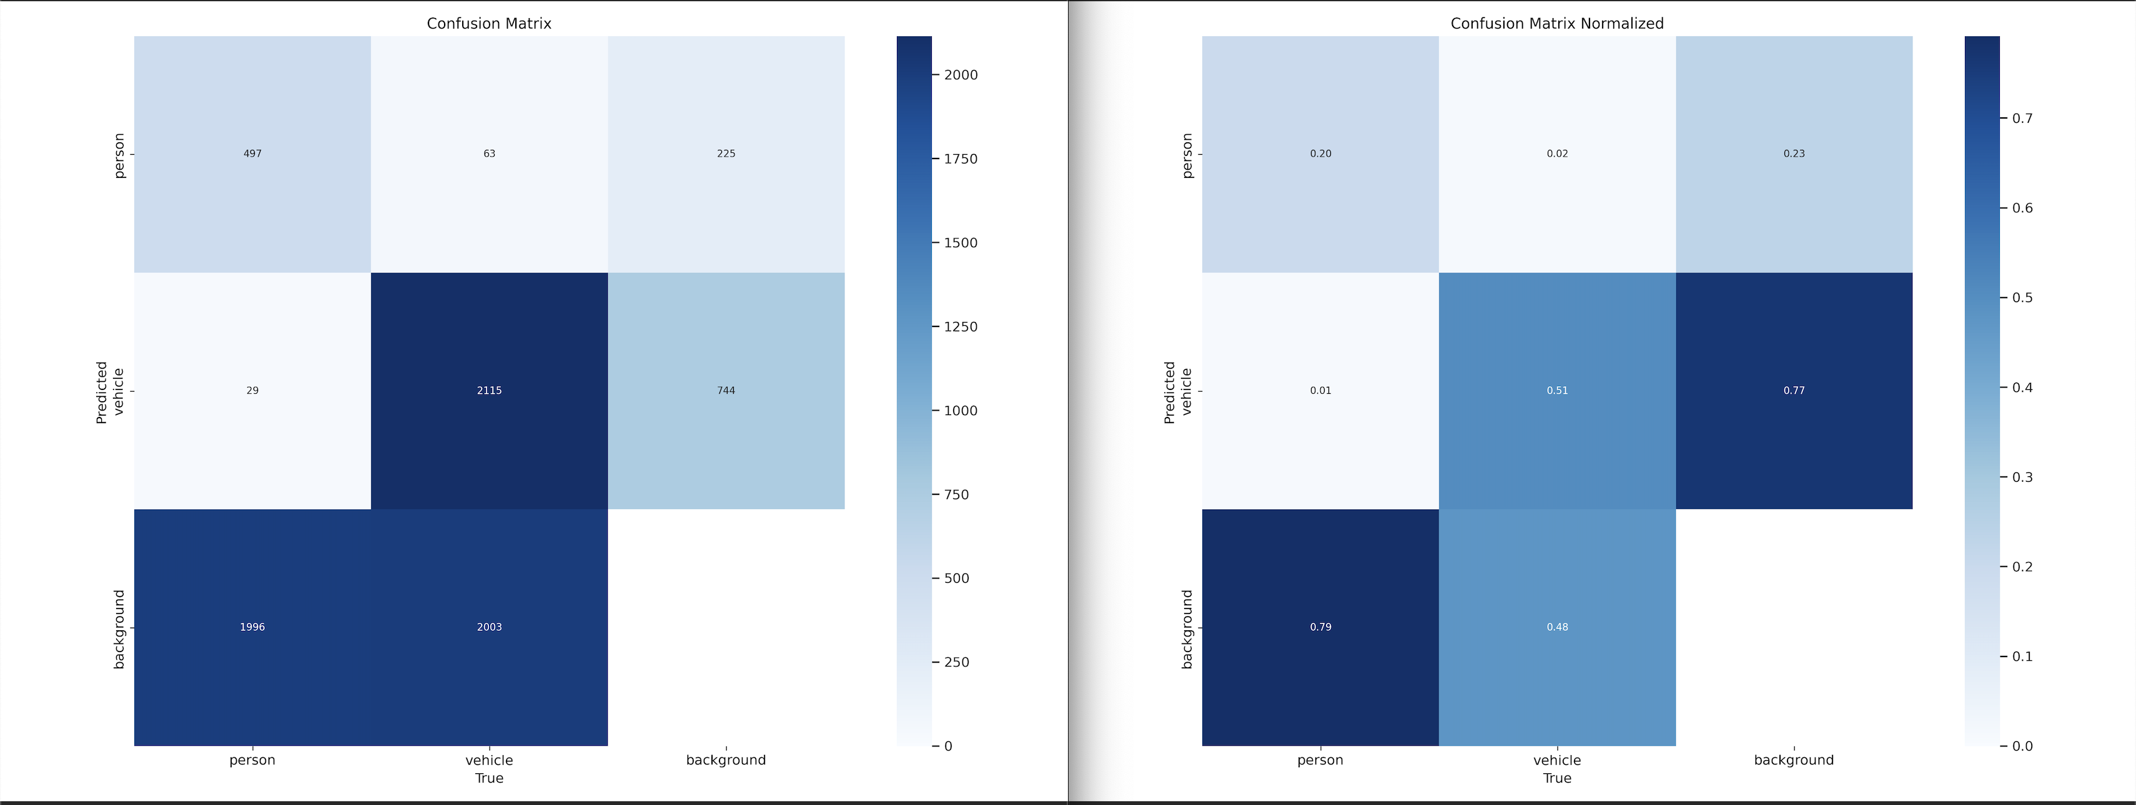

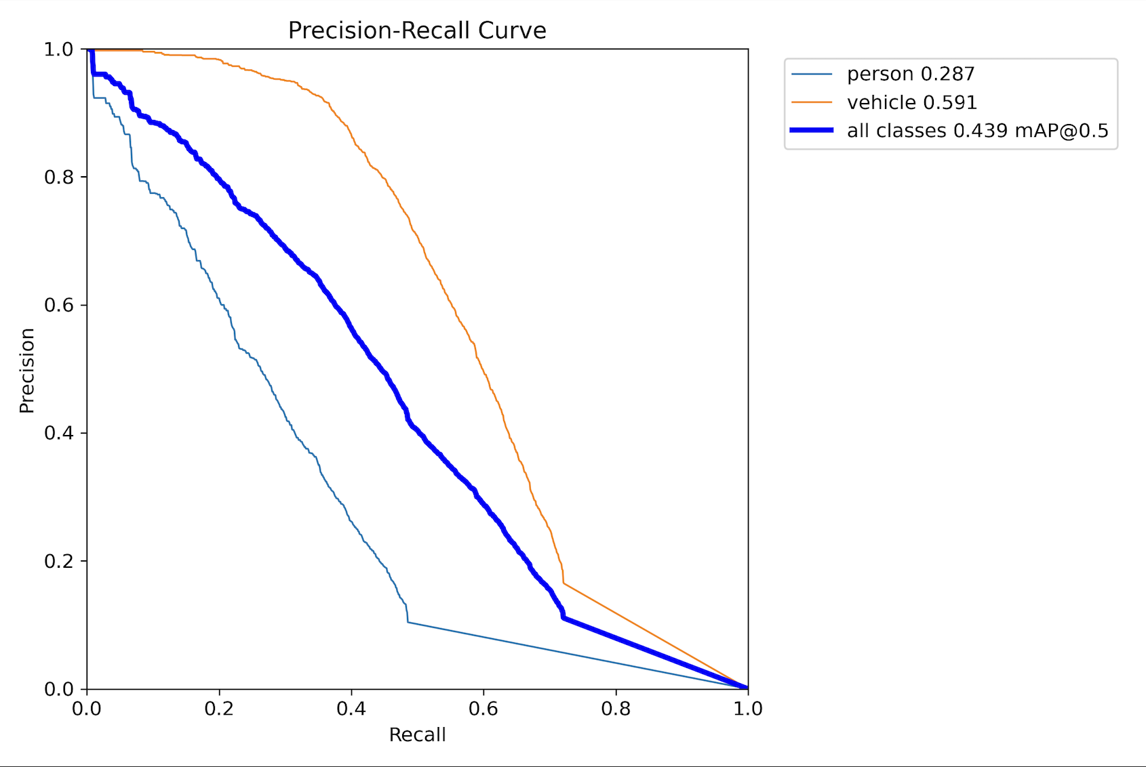

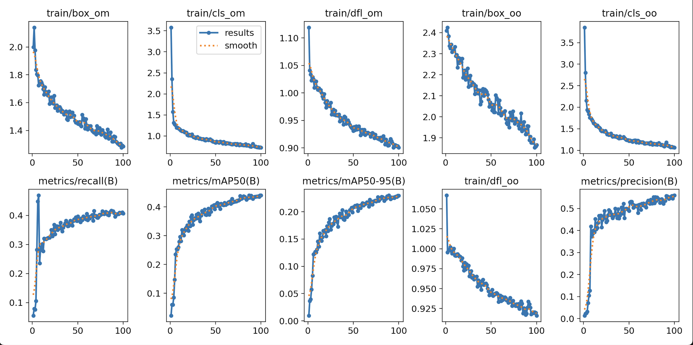

MODEL COMPARISON

